H E A
Overview Of

National Electronic Interstate Compact Enterprise (NEICE)

Information Exchange Package Document (IEPD)

Version 3.0

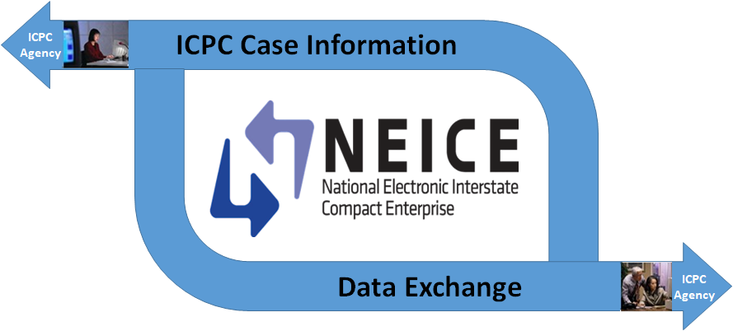

November 24, 2020

Table of Contents
Overview 2
Definitions 6
Background 8
1. Benefits of the NEICE 8
2. Business Process Flow 8
Secure Document Portal 10
List of IEPD Artifacts 12
1. Exchange Files 12
2. Instance Documents 12
3. Master Documentation Files 14
4. Other Documentation 14
5. Catalog Files 14
NEICE Project Team 15

Overview
This document provides technical information for state and county child welfare agencies working to implement the National Electronic Interstate Compact Enterprise (NEICE) to exchange Interstate Compact on the Placement of Children (ICPC) case information between state child welfare agencies when considering a placement of a child across state lines for foster care, adoption or residential treatment placements. NEICE is managed by the American Public Human Services Association (APHSA) on behalf of the Association of Administrators of the Interstate Compact on the Placement of Children (AAICPC). NEICE utilizes the National Information Exchange Model standards to translate the data from one state’s data system to another. This document provides background information on NEICE, the ICPC process, and the NEICE Information Exchange Package Document 3.0 that must be created to transmit the data through NEICE.

IEPD v.2, which all states are using as of December 2020,will continue to be operational and available to states while NEICE IEPD v.3 is being deployed to ensure state continuity. However, the NEICE team urges all states to switch to v.3 as soon as possible to access enhanced information flows and information.

This document provides:
- High level context about the Interstate Compact process on the Placement of Children across state lines,
- Background information about the National Electronic Interstate Compact Enterprise (NEICE) project and history, and
- A description of how ICPC case information will be transferred in an electronic manner between the state child welfare agencies.

Although each state child welfare agency performs similar functions and has committed to the ICPC process in their state laws, implementation of the ICPC may vary and may follow different flows because of a state’s internal IT structure or business processes. For example, some states are decentralized and counties handle ICPC work directly, while others are centralized, and all ICPC cases must flow through the central office.

This document presents the NEICE information sharing strategy that has already been implemented successfully across 35 different state IT systems and processes, as well as guidance for new states working to implement a connection to NEICE. More information about NEICE can be found here: www.aphsa.org/NEICE.

We urge new state partners to set up regular (weekly/bimonthly/monthly) calls with the NEICE technical team to ensure a smooth implementation process and avoid wasting staff resources pursuing approaches that other states may have already tried unsuccessfully.

NEICE History and Timeline

In 2012, the American Public Human Services Association (APHSA), as the Secretariat for the Association of Administrators of the Interstate Compact on the Placement of Children (AAICPC), approached the U.S. Office of Management and Budget (OMB) Collaborative Forum with the idea of an electronic exchange for ICPC data across state lines, and made the case for funding from the Partnership Program Integrity Innovation. The idea generated a more rigorous review and gathered momentum and input from a cross sector of government, community, and industry experts about how best to streamline and strengthen the idea for a pilot project.

The initial partnership came to life in 2013 when OMB transferred congressionally authorized federal funds to the Administration of Children and Families, Children’s Bureau as the lead federal agency to administer a pilot. The Children’s Bureau entered into a cooperative agreement with APHSA, as the secretariat for the AAICPC, to develop, implement, manage, and provide governance for the pilot. Since 2015, through support from the Children’s Bureau via extensions to the cooperative agreement, APHSA, AAICPC, state partners, and the Children’s Bureau have scaled the pilot successfully across the nation. The NEICE infrastructure includes:

- Cloud-based Case Management System (CMS) – Original CMS built during pilot and used by more than half of the states on NEICE
- Modular Case Management System (MCMS) – locally hosted within the state’s own infrastructure
- NEICE Clearinghouse – A two-way interface between the state’s SACWIS or CCWIS and the NEICE Clearinghouse (hub).

On February 9, 2018, President Trump signed into law the landmark bipartisan Family First Prevention Services Act, as part of Division E in the Bipartisan Budget Act of 2018 (H.R. 1892). Family First includes long-overdue historic reforms to help keep children safely with their families and avoid the traumatic experience of entering foster care, emphasizes the importance of children growing up in families and helps ensure children are placed in the least restrictive, most family-like setting appropriate to their special needs when foster care is needed. The act mandates that all states process their ICPC cases electronically by 2027 using an electronic case processing system; NEICE is the only national system that meets this requirement. With 35 live states today, and ten more joining soon, we are well on the way to having all 52 ICPC jurisdictions on board by 2027.

In 2019, the Children’s Bureau provided a grant to states dedicated to helping them implement the interstate electronic ICPC case data exchange leading to seven new states joining and five others to update or add the digital exchange.

Table 1 lists the 35 live states, the platform they use, and the date they went live in Production with the previous version of the IEPD Version 2.

Table 1 – State Connection Methods and Go Live Date
State | Connection Method | Go Live Date
Alabama | CMS | 5/30/17
Alaska | CMS | 1/30/17
Arizona | MCMS | 7/29/19
Arkansas | MCMS | 1/14/19
California | MCMS | 2/11/19
Connecticut | MCMS | 7/2/18
DC | CMS | 8/15/14
Florida | CMS | 8/15/14
Georgia | CMS | 3/14/17
Hawaii | CMS | 2/5/18
Idaho | Clearinghouse | 5/2/20
Illinois | CMS | 3/7/16
Indiana | Clearinghouse | 8/15/14
Iowa | CMS | 6/3/19
Kansas | MCMS | 10/1/18
Kentucky | Clearinghouse | 6/17/19
Louisiana | MCMS | 10/5/20
Maryland | CMS | 11/6/17
Mississippi | CMS | 5/30/17
Missouri | Clearinghouse | 11/18/19
Nebraska | MCMS | 11/28/15
Nevada | CMS | 8/15/14
New Mexico | MCMS | 1/22/18
New York | CMS | 8/4/18
North Carolina | Clearinghouse | 12/3/18
Ohio | Clearinghouse | 9/7/18
Pennsylvania | MCMS | 11/5/18
Rhode Island | CMS, MCMS | 3/28/2017, 10/12/2020
South Carolina | CMS | 8/15/14
South Dakota | MCMS | 7/23/18
Utah | CMS | 6/16/18
Vermont | MCMS | 7/5/19
Virginia | CMS | 4/18/16
Wisconsin | CMS | 8/15/14
Wyoming | MCMS | 3/11/19
Totals by system
CMS | 17
MCMS | 12
NCH | 6
On Board Total | 35

The map below shows the state status as of October 30, 2020.

Figure 1-National onboarding map

Definitions
This sub section defines the terms that are used throughout this document.
Child: A person, who by reason of minority, is legally subject to parental guardianship or similar control.
Sending Agency/State: The state where the sending agency is located, or the state in which the court holds exclusive jurisdiction over a child, which causes, permits or enables the child to be sent to another state.
Receiving Agency/State: The state to which a child is sent, brought or caused to be sent or brought, whether by public authorities or private persons or agencies, and whether for placement with state or local public authorities or for placement with private agencies or persons
Placement: The arrangement for the care of a child in a family free or boarding home or in a child-caring agency or institution but does not include any institution caring for the mentally ill, mentally defective or epileptic or any institution primarily educational in character, and any hospital or other medical facility.
Placement Resource: The person(s) or facility with whom the child has been or may be placed by a parent or legal custodian; or, placed by the court of jurisdiction in the sending state; or, for whom placement is sought in the receiving state.
ICPC Case Data: An organized record concerning an individual, their family and environment that includes social, medical, psychological and educational history and any other additional information that may be useful in determining appropriate placement.

Background

Benefits of the NEICE
The National Electronic Interstate Compact Enterprise (NEICE) is a multi-tenant data and document exchange accessed through either a case management system or a direct connection to a state child welfare information system. The NEICE supports the state and county child welfare agencies in implementing the Interstate Compact on the Placement of Children (ICPC) to transmit data and documents about possible placements between state jurisdictions. Two external evaluations of the NEICE system have found that NEICE significantly shortened the time it takes to place children across state lines, and saved participating states thousands of dollars in mailing and copying costs.

The evaluations found:
- Shortened processing time – Faster delivery of case information between the participating states lead to faster processing of children’s cases.
- Reductions in administrative costs – Initial reviews have shown that there are potential reductions in administrative costs.
- Reductions in Paper Costs – Achieves dollar savings in paper consumption, paper storage and handling, postage, courier, etc. as well as minimizes the staff burden of archiving records and destroying archived records according to State regulations.
- Error Reduction – Minimize double entry of any information. Single entry for electronic exchange reduces the opportunity for keystroke error and thus decreases the time spent by child support and judicial/legal agency staff correcting data entry errors.

ICPC Business Process Flow
State and County child welfare agencies, and in some cases, private contracted agencies, process ICPC cases. This process is extensive in order to ensure that children are placed safely across state lines, whether for foster care, adoption or residential treatment facilities/group homes. Figure 2 provides a simplified overview of how ICPC cases were processed before NEICE.

States are required to send all ICPC cases through the NEICE interface (including private cases such as Regulation 4 (residential treatment centers) and Regulation 12 (Private adoptions)) as outlined in the MOU signed between APHSA and the state.

PLEASE NOTE: If a state has restrictions on storing private data with its public child welfare data, the state should consider how to segregate the data when it comes in from NEICE, and when state and local case workers are building ICPC cases for Reg 4 or Reg 12. NEICE 2.0 has a separate field to designate whether a case is public or private.
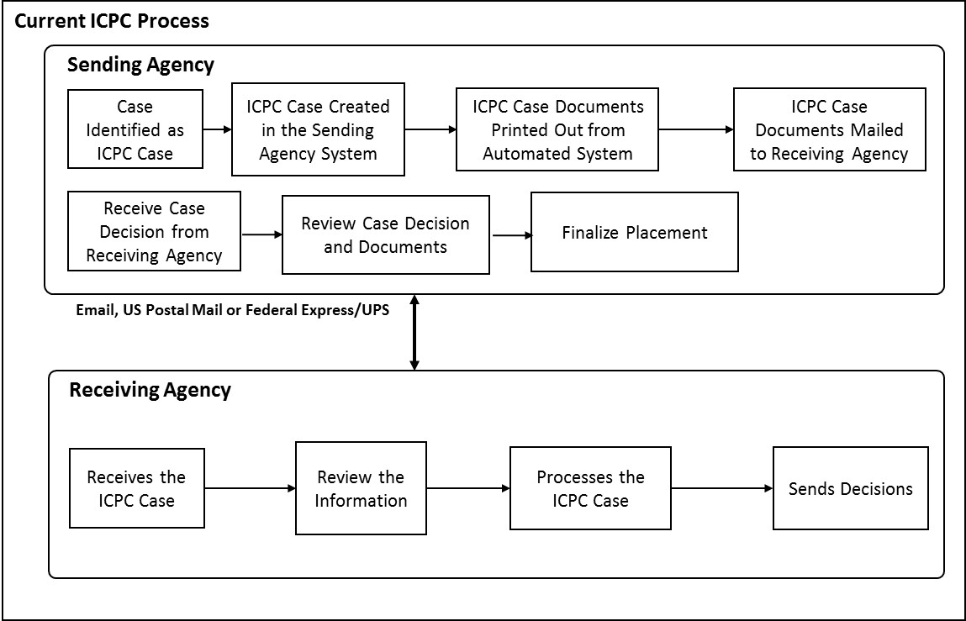
Figure 2, Paper-based Process
As depicted in Figure 2, the paper-based process (prior to NEICE) involves a number of steps; in fact, the entire process has approximately 39 documented steps. Once the case is identified as a potential ICPC case by the sending agency or state, an ICPC case file is created in the sending agency’s ICPC/state automated child welfare information system SACWIS. Once the documents in the file are reviewed and the case file determined to be complete, these documents are printed in multiple sets and sent to the Receiving Agency by US Mail, delivery service (Federal Express, UPS, etc.), fax, or email.

The receiving agency reviews this packet, which can be hundreds of pages long, to ensure all the required documents are present. They process the request (i.e., performs a home assessment, requests and reviews criminal background checks, etc.). When this process is completed, the receiving agency makes a determination on the home study request (i.e., approve or deny), and sends the decision to the sending agency. There may be a number of interactions between the two agencies, as well as between the various entities involved in the child welfare process within each state, before the decision about a potential placement for a child is determined.

The electronic process of sending an ICPC case through NEICE typically involves the state child welfare IT system creating the ICPC case and then sending the case to the recipient state using the NEICE Clearinghouse to exchange the data between systems. This is presented in Figure 3.

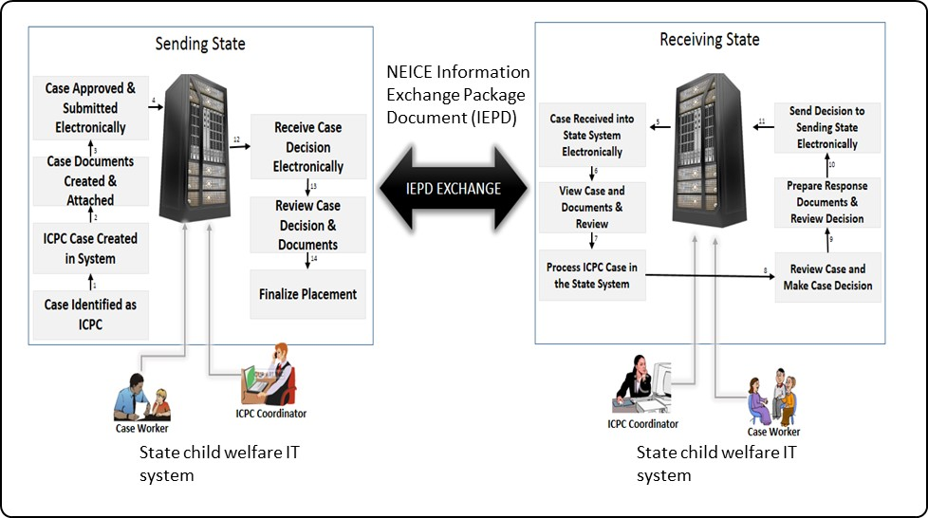
Figure 3, NEICE Electronic Exchange Process for ICPC Case Data
As depicted in Figure 3, the case workers/ ICPC coordinators create the ICPC case using the state child welfare IT system. Once the ICPC case data is complete and the case is ready to be sent to the receiving state, the sending state child welfare IT system creates an electronic data exchange packet containing the ICPC case data. This electronic data exchange packet is created in the format specified by the NEICE Information Exchange Package Document (IEPD), a document that specifies the manner in which the electronic data exchange packet needs to be created.

This electronic data exchange packet will be received by the receiving state child welfare IT system and ingested into the system for processing by the ICPC coordinators/ case workers in the receiving state. Once the placement request is processed, the decision is then sent back to the sending state for finalization of the placement.

As mentioned above, the NEICE Information Exchange Package Document (IEPD) document describes the manner in which the ICPC case data and the documents need to be formatted for transfer between participant states.

IEPD v.2 will continue to be operational and available to states while NEICE IEPD v.3 is being deployed to ensure state continuity. However, the NEICE team urges all states to switch to v.3 as soon as possible to access enhanced information flows and information.

Secure Document Portal
In addition to the electronic exchange that occurs between two states fully live in the NEICE system, a state which is working to go live in NEICE can send documents to states that are fully live in NEICE using the Secure Document Portal created in June 2020. The non-live state worker goes to a secure URL, uploads the case documents, and transmits to the receiving state which is live in the NEICE system. The receiving state receives an email notifying them that documents have been sent and to download the documents. Once they download the documents they receive, they can upload them into the fully operational NEICE system. The Secure Document Portal does NOT contain the case data. The SDP is a mechanism for NEICE Production states to exchange documents with states which are not yet fully implemented into NEICE. The fully live in NEICE states can send documents to the not-yet live in NEICE states by sending a transmittal from within NEICE directly to the not yet live in NEICE state, which receives an email to pick up the documents at the Portal. Currently, NEICE has 10 states which have signed MOUs but are not yet live in NEICE, and the Portal is available to these states.

List of IEPD Artifacts
This section lists the artifacts that are present in the NEICE IEPD package.
This IEPD package contains the XML artifacts such as the schema, instance documents, the mapping document, and the domain model. In addition, the IEPD package includes sample 100a and 100b documents (in PDF format) and a screenshot which is the UI used by the case workers in preparing the transmittal of a document to the peer state.
The content of the NEICE IEPD package is provided below.

Exchange Files
- Exchange Schema (neice_exchange.xsd)
- Extension Schema (neice_extension.xsd)
- Extension Schema - Enumerations (neice_codes.xsd)
- Subset Schema (folder titled niem)
- Wantlist (wantlist.xml)

Instance Documents

Additional Information

- NEICE_AdditionalInformation.xml
  - Sample XML Instance - Additional Information

Concurrence

- NEICE_ConcurrenceRequest.xml
  - Sample XML Instance - Concurrence Request

- NEICE_ConcurrenceResponse.xml
  - Sample XML Instance - Concurrence Response

Home Study

- NEICE_HomeStudyRequest.xml
  - Sample XML Instance - Home Study Request

- NEICE_HomeStudyRequest Reg 1 100A and 100B Maximal.xml
  - Sample XML Instance - Home Study Request for Regulation 1, fully populated

- NEICE_HomeStudyRequest Reg 1 100A and 100B Maximal (base 64 binaries removed).xml
  - Sample XML Instance - Home Study Request for Regulation 1, fully populated, with base 64 binary data removed for editing convenience

- NEICE_HomeStudyRequest Reg 1 100A and 100B Minimal.xml
  - Sample XML Instance - Home Study Request for Regulation 1, minimally populated

- NEICE_HomeStudyRequest Reg 1 100A and 100B Minimal (base 64 binaries removed).xml
  - Sample XML Instance - Home Study Request for Regulation 1, minimally populated, with base 64 binary data removed for editing convenience

- NEICE_HomeStudyRequest Reg 2 100A Only Maximal.xml
  - Sample XML Instance - Home Study Request for Regulation 2, fully populated

- NEICE_HomeStudyRequest Reg 2 100A Only Minimal.xml
  - Sample XML Instance - Home Study Request for Regulation 2, minimally populated

- NEICE_HomeStudyResponse.xml
  - Sample XML Instance - Home Study Response

- NEICE_HomeStudyUpdate.xml
  - Sample XML Instance - Home Study Update

Placement

- NEICE_PlacementConfirmation.xml
  - Sample XML Instance - Placement Confirmation

- NEICE_PlacementConfirmation_100B_Withdrawn.xml
  - Sample XML Instance - Placement Confirmation Withdrawn

- NEICE_PlacementConfirmation-100B_child_send_to_SS.xml
  - Sample XML Instance - Placement Confirmation, child sent to social services

- NEICE_Placement_Withdrawn.xml
  - Sample XML Instance - Placement Withdrawn

Progress Report

- NEICE_ProgressReportRequest.xml
  - Sample XML Instance - Progress Report Request

- NEICE_ProgressReportResponse.xml
  - Sample XML Instance - Progress Report Response

- NEICE_ProgressReport_FollowupRequest.xml
  - Sample XML Instance - Progress Report Followup Request

- NEICE_ProgressReport_FollowupResponse.xml
  - Sample XML Instance - Progress Report Followup Response

Status Report

- NEICE_StatusReportRequest.xml
  - Sample XML Instance - Status Report Request

- NEICE_StatusReportResponse.xml
  - Sample XML Instance - Status Report Response

- NEICE_StatusReport_FollowupRequest.xml
  - Sample XML Instance - Status Report Followup Request

Master Documentation Files
- NEICE-IEPD-MasterDocument.docx: Master Documentation (this document).

Other Documentation
- Sample 100a Document
- Sample 100b Document
- Transmittal Cover Sheet
- Domain Model
- NIEM Mapping
- Change Log

Catalog Files
- Catalog
- Metadata

NEICE Project Team

The NEICE project team listed below is available to answer any questions related with policy, technical or implementation.

Contact Name | Email | Project Role
Marci Roth | mroth@aphsa.gov | NEICE Director
Raghu Govindaraj | raghu@tetruscorp.com | NEICE Delivery Manager
Tom Livoti | tom.livoti@tetruscorp.com | NEICE Customer Support Lead
Susmita Linga | susmita.linga@tetruscorp.com | NEICE Technical Lead

